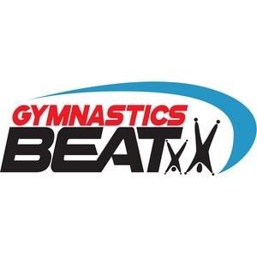



DECEMBER

NEWSLETTER

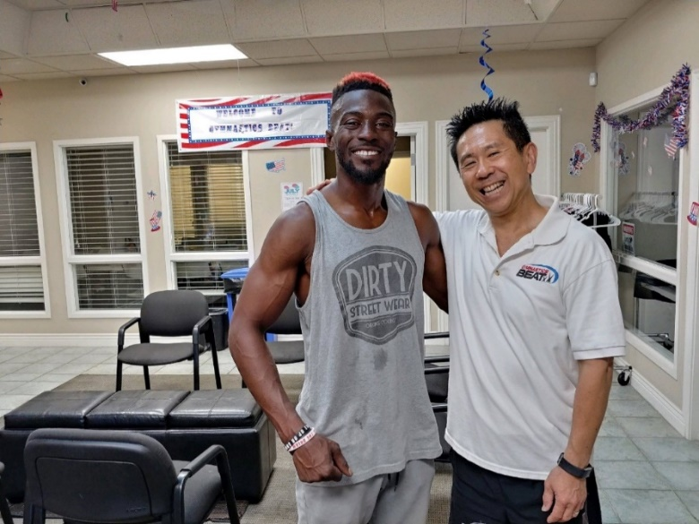

Last month, we all felt those extra pounds add on…. before, during and after Thanksgiving, right? We all say, it’s the holidays! Then by the time Christmas and winter break comes in full bloom, here comes January 1st and we’re busy trying to make our new year’s resolutions stick…. this time!

Well if you haven’t been reading our newsletters or getting our emails, or not checking in our social media posts, don’t be one of the ones who say: Gosh, I didn’t know that?! Is it too late?

Over 20 families bought our 50% off open gym annual passes for Christmas stocking stuffers! It was the start of our Black Friday specials! One dad asked if we had a special for the 2019 summer camp for all full days and he bought one after he knew the savings of over $600! We had a 3-month Dec/Jan/Feb tuition special and even more families bought them! For the next few weeks in December, you will be hearing more about upcoming special prices for our popular classes and camps, plus a new boot camp for parents to help shed those extra pounds we’ve gain for the past 2 months!... but please don’t pass up these savings! It may only come during these holidays! Once this crazy season is over, we wait again until next year!

For those who donate to charity, like Goodwill or Salvation Army, why not give to our non-profit For the Fun of Fit! Families in the past always ask us for our 501 (c )3 tax number and use it for their annual contribution! One pastor for a group home gave $1000 as his donated gift and utilized the tax savings! We in turn bought badly needed gym equipment for our facility! If you have a business and wish to advertise on our wall above the trampoline, think about buying in for a year or more of advertising space and use it for your marketing budget or tax deductions! Did you know last year, when we had our Grand Opening in October, Fresno Mayor Lee Brand attended as well as the head of EDC and head of the high-speed rail! They marveled at all the business advertisement on the wall!

And one last message.... Who wants to win $500? For those who have been here for a little while, please apply for our annual Sydney Weakley Scholarship! It’s easy, takes a few moments of your time and who doesn’t want scholarships? Imagine receiving a call on January 1st, that your family was picked to win $500 towards classes or team? What a great way to start the new year!

Happy Holidays and Merry Christmas to everyone!

SAM

SAYS

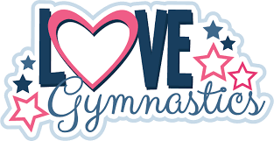

**LET THE KIDS RING IN THE NEW YEAR AT GYMBEAT!!!**

**New Year’s Sleepover (8pm 12/31 -9am 1/1)**

Ages: 6-12/ $50.00

**New Year’s Open Gym (8pm – 1am)**

Ages: 6 and Up/$35.00

**Early New Year’s Eve Celebration (5pm-8pm)**

Ages: 3-5 or 6-12/ $25.00

Drop by or call the front desk for all the fun details!!!

**PARENTS NIGHT OUT**

Finish your shopping, wrapping or a night out and let us watch the kids

December 22nd 5:30pm-8:30pm

Ages: 3-5 or 6-12/ $20 per child

Snacks/Crafts/Activities/Free Play

**Gold Medal Day is December 15th**

Join us in celebrating the accomplishments of your athletes. All recreational classes will perform.

Do not miss this opportunity to see your athletes up and close showcasing their talents!!!

Pre – Team Try outs

December 8th /10am-12pm



The Gym will be closed for classes

on the following dates:

* Sunday, Dec. 23rd - Wednesday, Dec. 26th
* Monday, December 31st
* Tuesday, January 1st

**Be on the lookout for our weekly specials as we**

**Countdown to Christmas**

**Don’t miss out on the savings….**

**Make sure to follow us on Facebook and Instagram**

**Check out our website at** [**www.gymnasticsbeat.com**](http://www.gymnasticsbeat.com)

**Or look for our weekly emails!!!**

AT



**Winter Camp!**

**December 17th-January 11th**

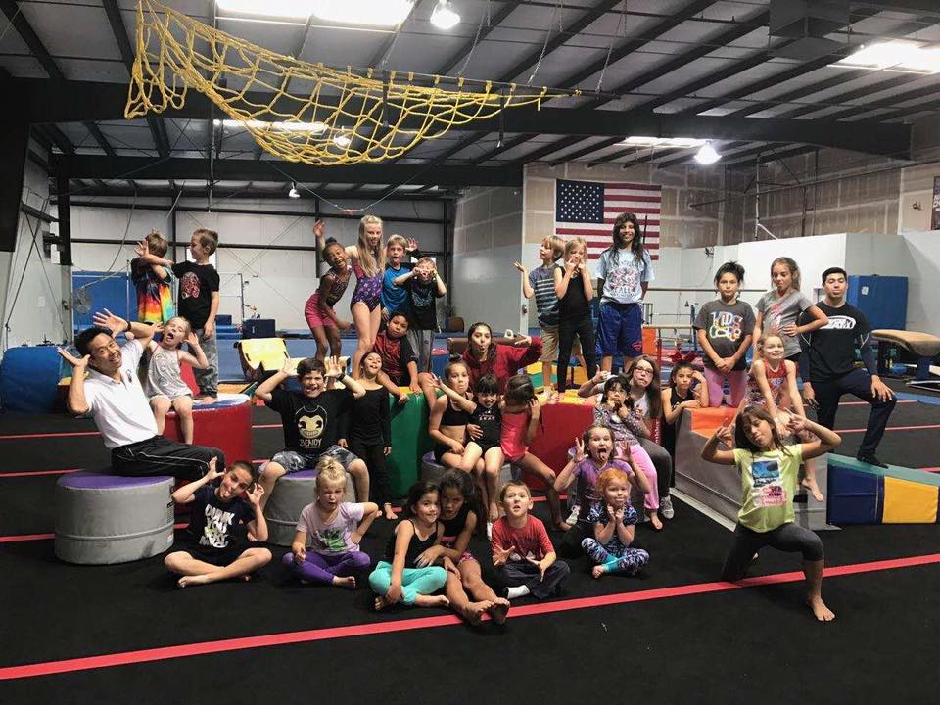

Games & Activities

Arts & Crafts

Obstacle Course

Free Play

& More!



**$35 Full Day Price – 8:30am-4:30pm- *must bring lunch**

**$25 Half Day Price – 8:30am-12pm or 1pm-4:30pm**

Register today at www.gymnasticsbeat.com

Important Open Gym Update!

As of December 1, 2018, we will no longer be having extended open gym on Friday nights. Friday open gym will run from 8pm-10:30pm.

Thank You, Management



**Moira Minner Joslynn Harvey**

**Lizzy Mckinlay Layla Ramos**

These amazing athletes have moved up to the

**Junior Olympic Team**

We want to take this opportunity to congratulate them on their commitment and tenacity.

Way to Go!!!

As they participate in their first competition of the season!

PacWest Invitational – Ontario – December 8th & 9th

**TEAM LUXOR**

Chloe Madison

Jennafer Kelly

Alejandro Elly

Destiny Vivica

Addison Emma

Mariah Haley

**TEAM CLEOPATRA**

Janae Tierra

Jocelyn Suriana

Maegen Lilyan

Tati Laniah

Celeste Jersie

**TEAM YOUTH GODDESS**

Chloe Reagan Joselyn Madison Ashley Khloe Cerenity Audrey Na’Zyia Destiny Addison Bella Keira Autumn



Interested in Cheer?

A new FUNdamentals 12-week session starts 1/18

New Year’s Resolution time?

We will be having a special boot camp for Teens and Adults

Dreamed of being a Competitive Gymnast?

Our new year of our Junior Olympic Team

STAY TUNED FOR MORE INFORMATION…

**January**

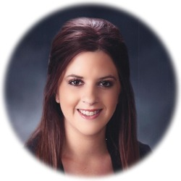

Sydney started out as a student with us almost about the time we opened our doors 15 years ago, grew up in our gym and became a wonderful coach and family friend of Gymnastics Beat. We still miss her smile and beautiful presence, but more importantly, her love for teaching pre-k and gymnastics will live on with this 2nd year of offering another scholarship to a deserving child. Our staff members and coaches will select the top 5 applicants we receive by December 15th, 2018 and will forward those names to the Weakley family. The honor and announcement of their choice will be given out on January 1st, the day Sydney passes, to the receiving family.

**$500 Scholarship Award**

Sydney A. Weakley

Memorial Scholarship

Dear Parents,

Most of you may not know this, but each year around this time, we are blessed to reach out to those families seeking out an athletic scholarship in the amount of $500.00 in the name and memory of our coach Sydney A. Weakley, who passed away in an automobile accident on January 1, 2017.

On a day we remember Sydney’s passing, will also be a heart-warming gift to a deserving athlete that Sydney would certainly be proud of!

Please come to our front office for any additional information or forms.

Scholarship is available to:

* Ages 4-18
* Currently Enrolled Students
* Team and Recreational Students

Submission must include the following:

* Application
* Video sent to [info@gymnasticsbeat.com](mailto:info@gymnasticsbeat.com)
* Parent essay
* Grade report or latest assessment

Applications can be downloaded from our website at [www.gymnasticsbeat.com](http://www.gymnasticsbeat.com) or at the Gymnastics Beat front office.

Application Submission Deadline:

On or before **December 14, 2018**

Gymnastics Beat will select five submissions to be finalists. The winner will be chosen by the Weakley Family from the five finalist submissions. Recipient will be notified by January 1st, 2019.



We would like to take this opportunity

to thank our Gymnastics Beat family

for your continued support.

**Wishing you and your families a joyous holiday!**

Add Gymnastics Beat on your social media to be the first to hear about all our latest news and upcoming events!

Have you added

Gymnastics Beat on

social media yet?

What are you waiting for?!

**FOCUS! ENERGY!**

New Ninja classes available NOW!

Baby Ninjas (walking-2years)

*This class is done with a parent

**Fridays 4pm-5pm**

Gymnastics Beat is adding 2 new ninja classes starting in December and you can sign-up for them now!

Ninja Tots (3 years-4 years)

**Thursdays 5pm-6pm**

More classes to choose from…

Are you 6 years old or older and interested in a boy’s gymnastics class? Gym Beat will be opening a boy’s gymnastics class level 1A Wednesdays at 6pm! See the front desk for details on how you can sign up today!





**Phone: (559) 271-9400**

**Fax: (559) 271-9500**

**Address: 4589 W. Jacquelyn Ave.**

**Fresno, Ca. 93722**

**www.gymnasticsbeat.com**

Sheyla Alonso 12/16

Alivia Castro 12/17

Katie Rosas 12/17

Aj Handy 12/18

Pierson Sherman 12/18

Emily Barron 12/18

Kailani Lee Cruz 12/18

Jocelyn Hernandez 12/19

Madison Bolanos 12/19

Kade Nickel 12/19

Penelope Beahm 12/20

Benjamin Kotheimer 12/21

Aylah Juarez 12/22

Demi Swartz 12/22

Emmy Monroe 12/22

Micayla Cain 12/23

Madlyn Barker 12/23

Bethany Skaggs 12/23

Najampreet Kaur 12/24

Devin Miguel 12/24

Ella Newton 12/24

Hayley Hirata 12/24

Samantha White 12/24

Sophia Cantu 12/26

Loren Kinsey 12/26

Quentin Lourenco 12/26

Kya Nickel 12/27

Sofia Aslanian 12/29

Audrey Groppetti 12/29

Camilla Sandoval 12/29

Kylee Quarles 12/29

Adrianna Gonzalez 12/02

Orion Obermiller 12/02

Carrie Bishop 12/02

Ava Garcia 12/03

**Stefan San Nicholas 12/03**

Emily Cantu 12/04

Makenzie Rocha 12/05

Sarai Morales 12/05

**Tasia Porter 12/6**

Maribelle Salas 12/06

Alondra Mireles 12/06

Kaley Enriquez 12/06

Natalie Andrade 12/07

Fallon Gutierrez 12/8

Lola Arambula 12/10

Pandora Lopez 12/10

Mckayla Fletcher 12/11

Maegen Lopez 12/12

Catricia Alvarez 12/12

Emily Enochs 12/12

Logan Moran 12/12

Aria Palacios 12/12

Shanna Pate 12/12

Kristina Khachatryan 12/12

Eliana Diaz 12/13

Joshlyn Huling 12/14

Elias Galarza 12/14

Mia Hagen 12/14

Christian Robbins 12/14

Joslynn Harvey 12/15